**Storage volumes:**

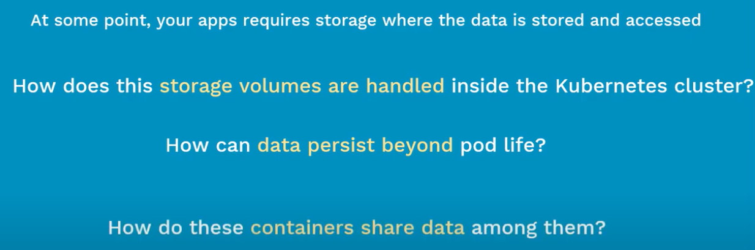

* Containers are stateless. It is not storing any data.
* These volumes can be used for the stateful apps which store the data inside POD.

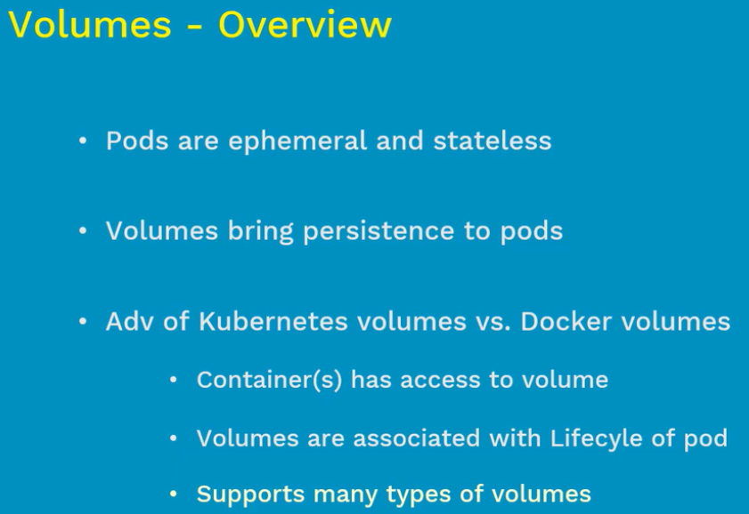

* Kubernetes volumes has much more features than docker volumes.

**Volume types:**

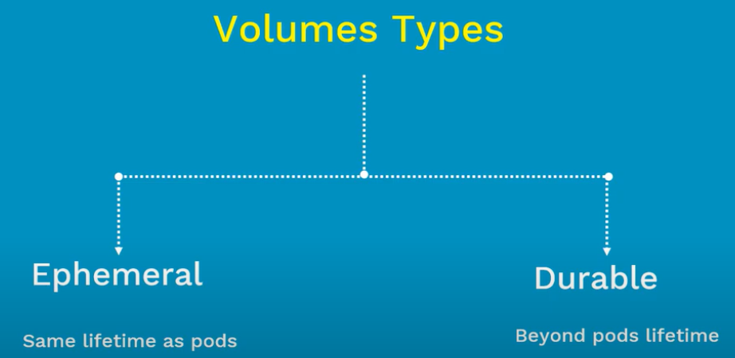

* Ephemeral are like temporary. It gets created with POD and gets deleted when pod dies.
* Durable volume gets created when POD created and stays even when POD dies. We can use that volume in any other POD to make use of the data.

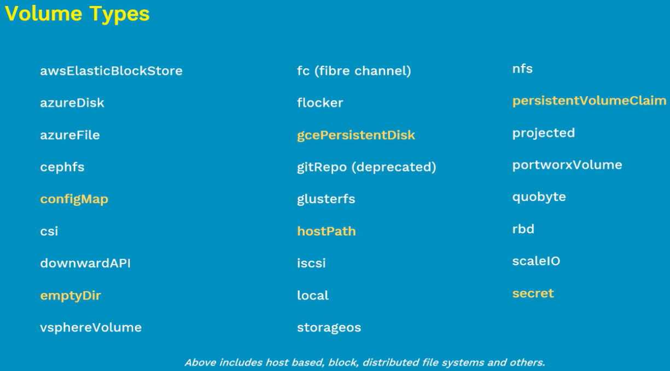

**EmptyDir:**

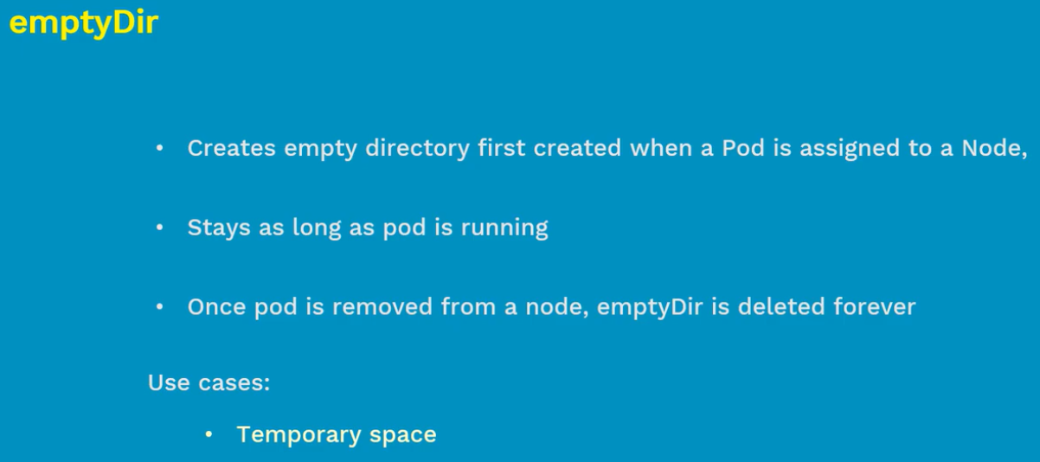

* This is for a temporary purpose to share the data between the containers in POD.
* This emptyDir gets created on node where the POD is scheduled. After that containers inside that POD can read/write the data into volume
* This volume gets deleted when POD is killed.

**hostPath:**

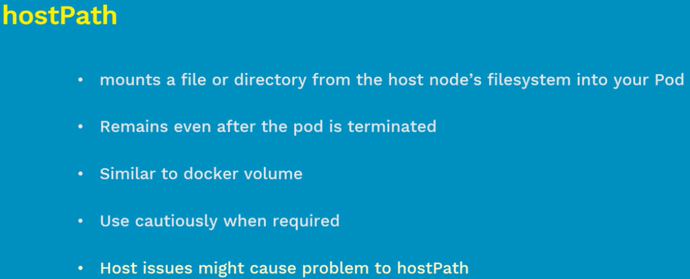

* Hostpath will exist even when we terminate the POD. Next time when we launch the pod in same node. It will be automatically picked up.
* We need to be careful with hostpath, because when we install a POD in multiple nodes across the cluster. This volume gets created in all nodes differently without syncing one to another.

**gcePersistantDisk:**

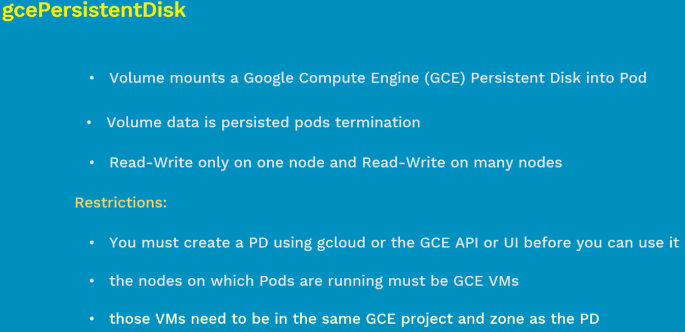

* AWS block storage and azure disk are similar to this with same restrictions.

**awsElasticBlockStore:**

